Paper title [Book Antiqua 20, bold, left alignment] | 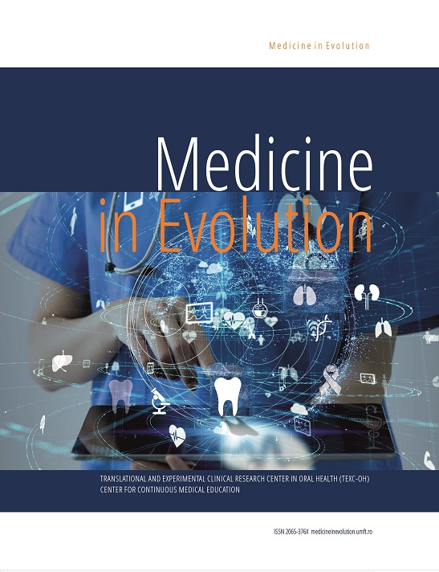
Surname Name, Surname Name [Book Antiqua, 14, bold]
¹ Author Affiliation (DEPARTMENT, FACULTY, UNIVERSITY, CITY/COMPANY, E-MAIL) [10, italic]
² Author Affiliation (DEPARTMENT, FACULTY, UNIVERSITY, CITY/COMPANY, E-MAIL) [10, italic]
Correspondence to:
Surname Name: [10, italic]
Address: [10, italic]
Phone: +40 [10, italic]
E-mail address: [10, italic]

Received: ____; Accepted: _______; Published: _________

Abstract [Book Antiqua, 12, bold, justify alignment]
The abstract should not exceed 200 words in total. It should be presented as a single paragraph and structured following the format of structured abstracts, but without individual headings. 1.Background/Objectives: Introduce the purpose of the study, including the research question(s), and provide relevant contextual information. 2.Methods: Briefly outline the main methods or treatments utilized in the study. Include any pertinent preregistration numbers and specify the species and strains of any animals involved. 3.Results: Summarize the primary findings of the article.4.Conclusion: Provide the main takeaways and interpretations derived from the study. The abstract should offer an objective representation of the article, refraining from including results that are not presented and substantiated in the main text.
Keywords: Three to ten pertinent keywords need to be added after the abstract. We recommend that the keywords are specific to the article, yet reasonably common within the subject discipline.

INTRODUCTION [Book Antiqua, 11, bold, left alignment]
The introduction section serves to provide a concise overview of the study's broader context and underscore its significance. It should outline the purpose of the work, including the specific hypotheses being tested, and articulate its relevance. Careful consideration of the current state of the research field is essential, with key publications cited to contextualize the study. Controversial or diverging hypotheses should be highlighted where applicable. Additionally, briefly outlining the primary aim of the work and highlighting the main conclusions is advised. The introduction should maintain comprehensibility for scientists working outside the paper's specific topic. [Book Antiqua, 11 point, normal, justified alignment]

Aim and objectives [Book Antiqua 11, bold italic, left alignment]
The text included in the sections or subsections must begin one line after the section or subsection title. Do not use hard tabs and limit the use of hard returns to one return at the end of a paragraph. Please, do not number manually the sections and subsections; the template will do it automatically.
[Book Antiqua, 11 point, normal, justified alignment]

MATERIAL AND METHODS [Book Antiqua, 11, bold, left alignment]
The methods should be presented in a manner that provides ample detail for others to replicate and extend upon the published results. Newly developed methods and protocols should be described comprehensively, while established methods can be summarized briefly and referenced appropriately. It is important to specify the name and version of any software utilized and indicate the availability of computer code used. Additionally, inclusion of pre-registration codes is encouraged. [Book Antiqua, 11 point, normal, justified alignment]

FIGURES, SCHEMES AND TABLES
- Figures and schemes files should should have a minimum width/height of 1000 pixels or a resolution of at least 300 dpi. Recommended formats include TIFF, JPEG, PDF, and PNG.
- Each figure, scheme, and table should include an explanatory title and be inserted into the main text after its initial citation. They should be sequentially numbered based on their order of appearance (e.g., Figure 1, Scheme I, Table 1, Figure 2, Scheme II, Table 2, etc.).
- Tables should feature clear column headings. While smaller fonts may be used according to the provided Word template, they should generally not be smaller than 8 points. Microsoft Word's Table option should always be utilized for table creation

RESULTS [Book Antiqua, 11, bold, left alignment]
Provide a concise and precise description of the experimental results, their interpretation as well as the experimental conclusions that can be drawn. [Book Antiqua, 11 point, normal, justified alignment]

DISCUSSIONS [Book Antiqua, 11, bold, left alignment]
Authors are expected to analyze the results and interpret them in the context of previous studies and the working hypotheses. The discussion should encompass the findings and their implications within the widest possible context, while also acknowledging the limitations of the work. Suggestions for future research directions may also be included. [Book Antiqua, 11 point, normal, justified alignment]

CONCLUSIONS [Book Antiqua, 11, bold, left alignment]
Conclusions should be concise, underlining the most significant results and their value for the research community. [Book Antiqua, 11 point, normal, justified alignment]

Patents [Book Antiqua 11, bold italic, left alignment]
This section is not mandatory but may be added if there are patents resulting from the work reported in this manuscript. [Book Antiqua, 11 point, normal, justified alignment]

Acknowledgments [Book Antiqua 11, bold italic, left alignment]
In this section, you have the opportunity to express appreciation for any assistance provided that may not be covered in the author contributions or funding sections. This could encompass administrative and technical support, as well as in-kind donations such as materials used for experiments. [Book Antiqua, 11 point, normal, justified alignment]

Conflicts of Interest [Book Antiqua 11, bold italic, left alignment]
Authors must identify and declare any personal circumstances or interest that may be perceived as influencing the representation or interpretation of reported research results. If there is no conflict of interest, please state "The authors declare no conflict of interest." Any role of the funding sponsors in the choice of research project; design of the study; in the collection, analyses or interpretation of data; in the writing of the manuscript; or in the decision to publish the results must be declared in this section. [Book Antiqua, 11 point, normal, justified alignment]
REFERENCES [Book Antiqua, 11, bold, left alignment]
A numbered list of references must be provided at the end of the paper. The list should A numbered list of references must be provided at the end of the paper. The list should be arranged in the order of citation in the text of the publication, assignment or essay, not in alphabetical order (according to the Vancouver rules). List only one reference per reference number. It is very important that you use the correct punctuation and that the order of details in the references is also correct.
- Books - Standard format - #. Author of Part, AA. Title of chapter or part. In: Editor A, Editor B, editors. Title: subtitle of Book. Edition(if not the first). Place of publication: Publisher; Year. p. page numbers.
- Journal Articles - Standard format - #. Author of article AA, Author of article BB, Author of article CC. Title of article. Abbreviated Title of Journal. year; vol(issue): page number(s).
- E-Books - Standard format - #. Author A, Author B. Title of e-book [format]. Place: Publisher; Date of original publication [cited year abbreviated month day]. Available from: Source. URL.
- E-Journals - Standard format - #. Author A, Author B. Title of article. Abbreviated Title of Journal [format]. year [cited year abbreviated month day]; vol(no): page numbers [estimated if necessary]. Available from: Database Name (if appropriate). URL.
- Internet Documents - Standard format - #. Author A, Author B. Document title. Webpage name [format]. Source/production information; Date of internet publication [cited year month day]. Available from: URL

